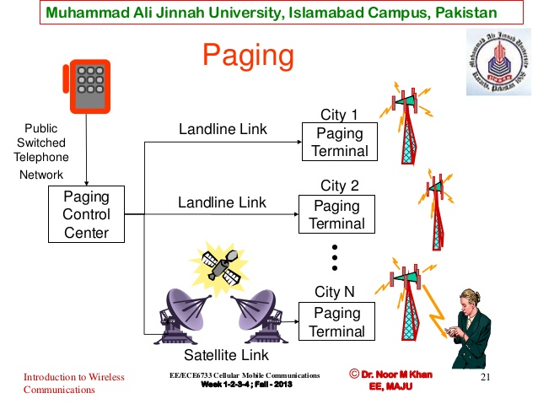

Muhammad Ali Jinnah University, Islamabad Campus, Pakistan

Paging
• Paging systems are wireless
communication systems tha...

Muhammad Ali Jinnah University, Islamabad Campus, Pakistan

Cordless System
• Cordless telephone (CT) is a
communication s...

Muhammad Ali Jinnah University, Islamabad Campus, Pakistan

Cordless Telephone
Public
Switched
Telephone
Network
(PSTN)

W...

Muhammad Ali Jinnah University, Islamabad Campus, Pakistan

Wireless LAN Standards
• 802.11b (Earlier Generation)
– Standa...Muhammad Ali Jinnah University, Islamabad Campus, Pakistan

Wireless LAN Standards
• 802.11n, ac (Next Generations)
– Stan...

Muhammad Ali Jinnah University, Islamabad Campus, Pakistan

WiFi Standards Comparison Table
802.11b
IEEE Ratified
Frequenc...

* Application: supporting network applications
  + FTP, SMTP, HTTP
* Transport: data transfer between processes
  + TCP, UDP
* Network: routing of datagrams from source to destination
  + IP, routing protocols
* Link: data transfer between neighboring network elements
  + Ethernet, WiFi
  + Physical: bits “on the wire”
  + Coaxial cable, optical fibers, radios